Winners of 2025 Ukrainian Holodomor Student Competition announced
by OKSANA KULYNYCH3 MINS READUPDATED:MAY 16, 2025 9:30 AM
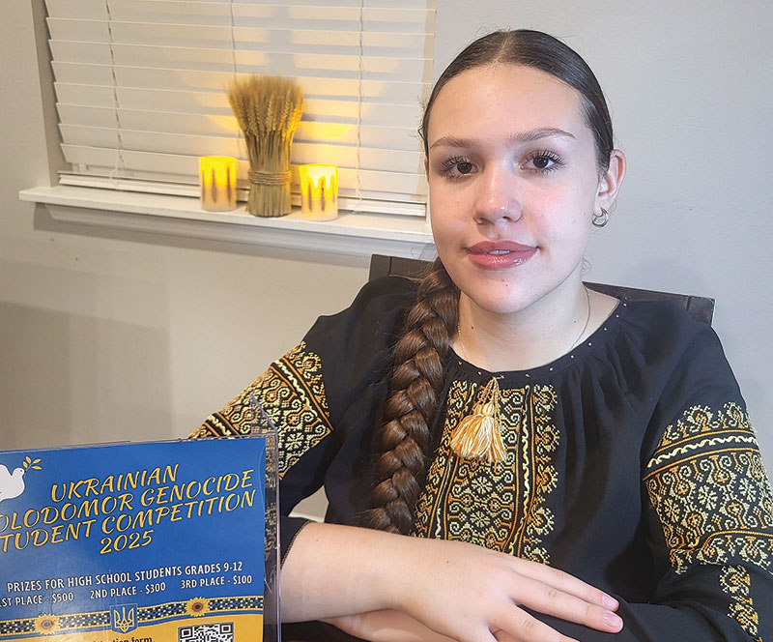Courtesy of the Holodomor Student Competition SubcommitteeMaria Ustymenko of Wiregrass Ranch High School in Florida won the 2025 Holodomor Student Competition in the grades 9-10 category.

The Ukrainian Holodomor Student Competition Subcommittee of the U.S. Committee for Ukrainian Holodomor Genocide Awareness is very pleased to report on the success of the Holodomor Student Competition. It is gratifying to see that, with everything going on in the world, students chose the topic of the 1932-1933 Ukrainian Holodomor, which many students connected to Russia’s current genocidal war against Ukraine. The committee noted that it was very impressed with the quality of the submissions and said It was evident that students had spent a great deal of time researching their projects.
The winners of the competition in the grades 11-12 category were Elyna Gamboa of Dighton Rehoboth Regional High School in Massachusetts and Chloe Eng of Manhasset Secondary School in New York who tied for first place, while Matthew St. Andre of Notre Dame Preparatory School in Michigan took second place and Dahlia Iuliano of Immaculate Heart Academy in New Jersey took third place. Chloe Coll of Immaculate Heart Academy in New Jersey received an honorable mention.
The winner in the grades 9-10 category was Maria Ustymenko of Wiregrass Ranch High School in Florida, while Yaryna Hryshchuk of St. Joseph Academy in Ohio and Daniel Kocan of Masuk High School in Connecticut were tied for second place. There was no third place winner.
Teachers noted how passionate their students were about the topic.
“It created an amazing discussion with students who had previously not been exposed to the Holodomor,” said teacher Katherine Beckett.
Teacher Emily Woznick said that her student did a fantastic job not only touching upon the turmoil Ukrainians faced and continue to face, but also celebrating the resilience of the Ukrainian people.
Winners of the competition received prizes of $500 for 1st place, $300 for 2nd place, and $100 for 3rd place; winnings who were tied will share the prize money. Winning schools will also receive an award of $75, $50, $25 respectively to be used toward the purchase of materials to enhance the study of the Holodomor.
Organizers of the competition expressed thanks to everyone who participated in this year’s Holodomor Student Competition. More information about the competition can be obtained by emailing ukrainecompetition@gmail.com.
Oksana Kulynych is the chair of the Holodomor Student Competition Subcommittee of the U.S. Committee for Ukrainian Holodomor Genocide Awareness.

